**ANALYSIS OF IRIS DATASET**

|  |  |  |
| --- | --- | --- |
| Student ID: 23082951  GitHub Link: |  |  |

**Introduction:** This dataset is taken from Kaggle. It consists of 150 observations of iris flowers, mainly three different species: Iris setosa, Iris versicolor, and Iris virginica. Each observation has four different features: sepal length, sepal width, petal length, and petal width, which are measured in centimeters.

**Histogram Plot:** The given plot illustrates the distribution of the sepal length of the iris dataset. It is evident from the graph that the distribution is close to normal with a slight positive skewness. The mean and median value of the sepal length is **5.84**cm and **5.80**cm. The standard deviation value is **0. 83**cm. The skewness value is **0.31** and the kurtosis value is –**0.55.**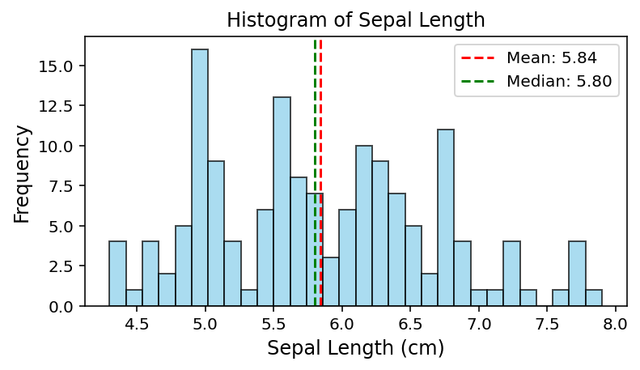

**Scatter Plot- Cluster with Line Fitting:** The given scatter plot illustrates the bonding between sepal length and petal length of the species Iris-virginica.It indicates a strong positive correlation as the data points are clustered around the line fitting. It is evident from the graph that there exists a linear relationship between the two variables as both increases simultaneously.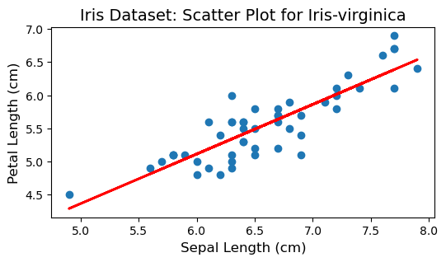

**Correlation Matrix of Iris Dataset: Heat map**

The given correlation matrix demonstrates a strong positive connection between petal length and petal width (**0.94**), and between sepal length and both petal width (**0.88**) and petal length (**0.87**). A moderate positive relationship of value **0.73** is observed between sepal length and sepal width. The heatmap shows a negative value with petal length of **–0.41** and petal width of **–0.3** illustrating a weak relationship between them.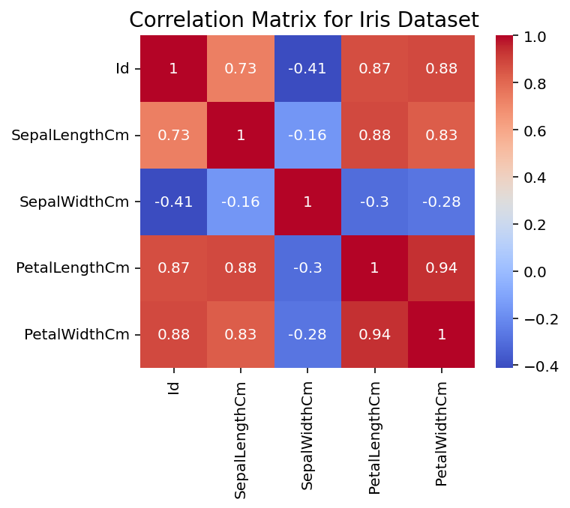

**Elbow Method and K-means Clustering:**

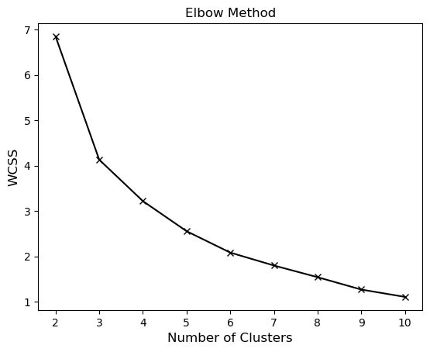This graph is used to determine the optimal number of clusters in K-mean clustering using elbow method. As the number of cluster increases, the WCSS decreases. A slowdown in rate of decrease is observed after a certain point as result an "elbow” shape is formed. In this figure, the elbow appears to be around 3 or 4 clusters. This means that a good balance between separation of the data and compactness can be provided using 3 or 4 clusters.

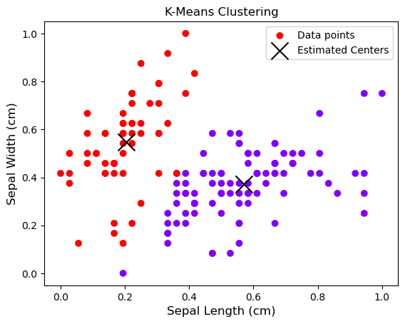**K-mean clustering:** The graph represents the analysis of K-means clustering applied to iris dataset by visualizing two features (sepal length and sepal width). The two different colors (blue and red) the data points that are divided into two distinct clusters. The centers of each cluster (estimated centers) are denoted by the symbol ” X”. It is clear from the graph that the two clusters are separated well, indicating that the K-means algorithm has accurately identified two distinct groups within the data.

**Conclusion:**

This report highlights the clustering and statistical properties of the data by proper analysis of the iris dataset. From the histogram, the distribution of sepal length is observed along with all its major moments: mean, median, standard deviation, skewness and kurtosis. From the scatter plot a strong linear relationship is observed between sepal length and petal length of the Iris-virginica species. The heatmap demonstrates a correlation between various features of the dataset.

The elbow method is used to find the optimal number of clusters of K-means clustering which showed around 3 or 4 clusters. The dataset was successfully divided into two distinct groups showing the accuracy of K-mean algorithm in identifying the natural patterns in data. These outcomes indicates that these clustering techniques and statistical analysis can be utilized for interpreting and exploring complex dataset.